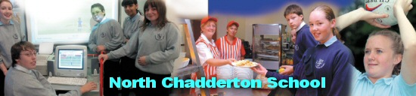
Science Department Review: 2007

Risk Taking

Innovation
Global and Local Communities
Local and World Issues

Sharing Ideas and Expertise
Business and Enterprise Activities

Integrating ICT within Science

Developing individual skills
Focus on Teamwork
and collaboration

